21BDS0340

Abhinav Dinesh Srivatsa

Database Systems Lab

Assignment – III

**Exercise – V**

1. Retrieve the names of all employees in department 5 who work more than 10 hours per week on product X project

Command:

select e.f_name, p.name, wo.hours from works_on_bds0340 wo, employee_bds0340 e, project_bds0340 p where wo.emp_ssn = e.ssn and wo.proj_num = p.num and e.dept = 5 and wo.hours >= 10;

Output:

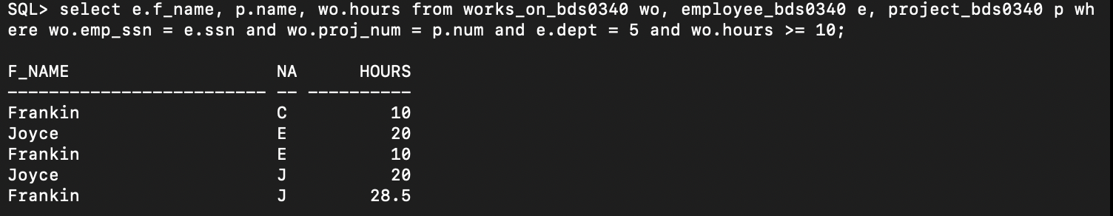

1. List the names of all employees who have a dependent with the same first name as themselves

Command:

select e.f_name, e.m_name, e.l_name from employee_bds0340 e, dependent_bds0340 d where d.emp_ssn = e.ssn and d.name = e.f_name;

Output:



1. Find the names of all the employees who are supervised by ‘Franklin’

Command:

select e1.f_name, e1.m_name, e1.l_name from employee_bds0340 e1 join employee_bds0340 e2 on e1.super_ssn = e2.ssn where e2.f_name = 'Frankin';

Output:

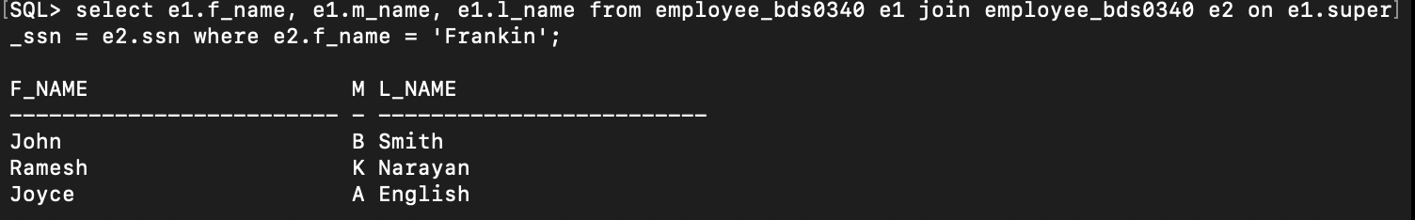

1. Retrieve the names of the employees who do not work on any project

Command:

select e.f_name, m_name, l_name from employee_bds0340 e left join works_on_bds0340 wo on wo.emp_ssn = e.ssn where wo.proj_num is null;

Output:

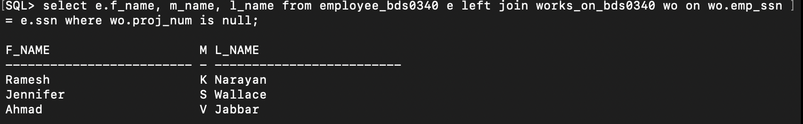

1. Find the names and addresses of all employees who work on at least one project located in Houston but whose department has no location in Houston

Command:

select e.f_name, e.m_name, e.l_name, e.address from employee_bds0340 e inner join works_on_bds0340 w on e.ssn = w.emp_ssn inner join project_bds0340 p on w.proj_num = p.num inner join department_bds0340 d on e.dept = d.num left join dept_location_bds0340 dl on d.num = dl.dept_num where p.location = 'Houston' and dl.dept_loc <> 'Houston';

Output:

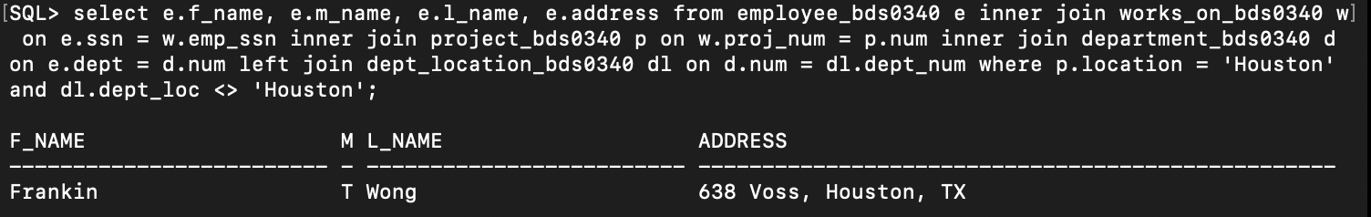

1. List the names of all managers that have no dependents

Command:

select e.f_name, e.m_name, e.l_name from employee_bds0340 e left join dependent_bds0340 d on d.emp_ssn = e.ssn where d.emp_ssn is null;

Output:

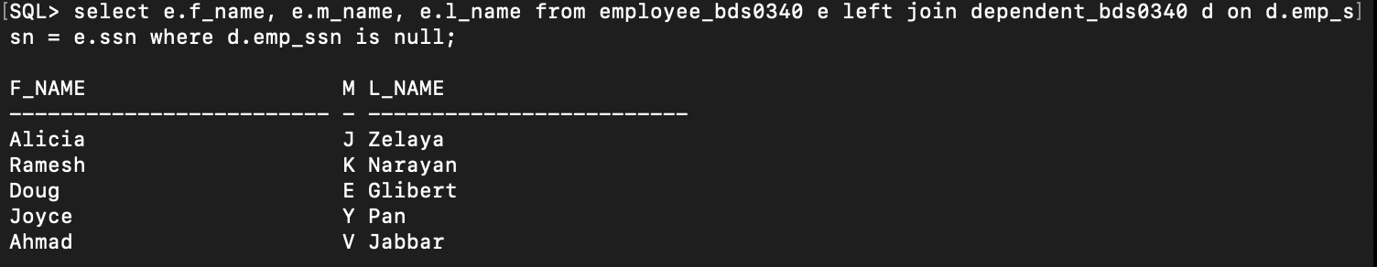

1. List the employee names and the department names if they happen to manage the department

Command:

select e.f_name, e.m_name, e.l_name, d.name from employee_bds0340 e left join department_bds0340 d on d.mgr_ssn = e.ssn;

Output:

1. For each project, retrieve the project number, name and the number of employees who work on the project

Command:

select p.num, p.name, count(w.emp_ssn) from project_bds0340 p join works_on_bds0340 w on w.proj_num = p.num group by p.num, p.name;

Output:

1. For each project, list the projects name and the total hours (by all employees) spent on that project

Command:

select p.name, sum(w.hours) from project_bds0340 p inner join works_on_bds0340 w on w.proj_num = p.num group by p.name;

Output:

1. Retrieve the names of employees who have 2 or more dependents

Command:

select e.f_name, e.m_name, e.l_name, count(d.name) from employee_bds0340 e inner join dependent_bds0340 d on e.ssn = d.emp_ssn group by e.f_name, e.m_name, e.l_name having count(d.name) >= 2;

Output:

